Glossy
A companion to Paratext & 8.
Displays lexicons from Paratext interlinearizer in an easy searchable form.
Author: David Rowbory david_rowbory@sil.org
Version: 1.6 – Dec 2017
Copyright © 2011–2017 David Rowbory, Free software licensed under GPL v3. See COPYING.TXT.
Thanks to Mark Gaddis for the original idea, Milt Jones, Jeremy Lang, John Heins and several others for ideas/bug-reports along the way. See the end of this doc for the recent changes.

Why might I want to use glossy?
If you’re a consultant using the Paratext interlineariser to account for vernacular words in a translation project and you would like to
- Find related words based on searching for parts of either vernacular or glosses.
- Show all the ways a word or related words have been glossed.
- Search for inconsistent spellings based on glosses.
- Grab the file and put it in Excel to investigate it a bit more.
A live concordance and various other statistics would be nice, but I haven’t done that yet.

How to install
- Copy the glossy folder into your My Paratext Projects folder or anywhere else on your computer.
- Make a shortcut to the go.bat file and the display_glossies.html file from that folder and put them somewhere convenient.

How to run glossy
- If you are going to be using Paratext and adding to the lexicon, then:
  - Open Paratext first.
  - Run the go.bat batch file. This watches for changes from Paratext and automatically stops when you stop using Paratext for a while.
- Open the display_glossies.html file in Firefox, Internet Explorer or Safari (not Chrome).
  - (If you use Chrome, open the open_glossy_chrome.bat file.)
  - Then choose a language from the list at the top.

What you can do with the list
Glossy shows you the quick lexicon generated from the Paratext interlinearizer.
Search: Type anything in the search box at the top to search for it.
Starts with: Type one letter to show only words starting with that letter.
Sort: Click a column heading to search by that column.
(Sort from the end by double-clicking the search box; it will turn red. Double-click again to go back to sorting from the left.)
Find this: Click on any word to search for that word. Good for finding similar words.
Copy to Excel: Press tab then ctrl-A (select all) then ctrl-C to copy the whole table then paste into Excel for further sorting.
Refresh to see recent changes: If you’ve made many changes to interlinearised text in Paratext, you can reload the list by telling the browser to refresh the page (F5 on Windows). The batch file you run watches for changes and keeps everything up to date.
Give it to someone else: You can easily take the whole sortable, searchable lexicon to another computer by copying the whole glossy folder, complete with the appropriate xxx_Lexicon.xml file, where xxx is the Paratext project code.
- If you remove any lexicon files you don’t want people to use, you’ll either have to tell people to load the Lexicon.xml file directly or else edit the lex_list.html file to remove references to the removed lexicons.

What it should look like:
Showing 3 different lexicons in: Firefox 12, Chrome 18, Internet Explorer 9
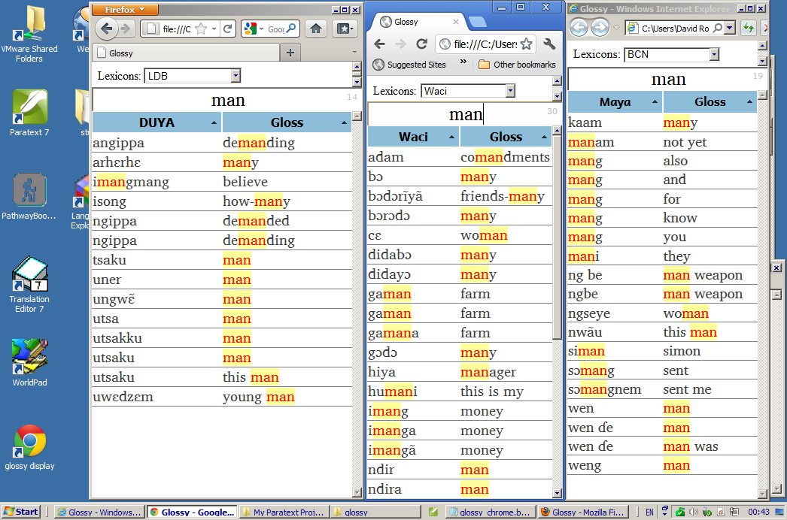
It looks nice on a Mac too, but Paratext doesn’t run on a Mac except through Virtualization. It’s been designed so that you can make it a tall and slender window just to the side of Paratext. You could hide some of the menu bars and tool bars if you like.

Special instructions:
Some versions of Internet explorer need you to click Allow blocked content before it displays the table.
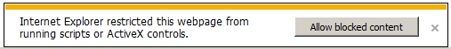

Reporting problems and suggesting improvements
Please let me know if this version of glossy works well in your browsers, if you have problems or suggested improvements. I would especially like some more testing in other web browsers such as Opera, Internet Explorer 6, IE 7, IE 8 etc. Patches to the source code would be appreciated and may be included. There is a lot of scope for improvement, but the primary design goal is a minimalist, uncluttered user interface. I haven’t consciously optimised the code for speed and haven’t needed to yet, but I could do that if a problem is demonstrated.
Email: glossy@m.rowbory.co.uk

Known Defects
- Sorting from the right/end is not Unicode aware, so letters with diacritics behave oddly. Tell me if this bothers you enough for me to do something about it; a fix potentially might make it work slower.

Changelog

1.5 (June 2014)
- made the run_glossy_watcher batch file more robust, renamed it go.bat (Thanks to Milt Jones for ideas)
- added sort from right/end (Thanks to John Heins for the suggestion)

1.4 (July 2012)
- display_glossies.html: unnecessary scrollbars removed

1.3 (June 2012)
- Removed faulty encryption set on some subfolders which generated spurious error messages.
- Reworked batch file to work on 64 bit machines. You can also see in the batch file how you could make it work for installation in other places.

1.2 (May 2012)
- Removed unnecessary restriction about where glossy folder needed to be. It should run happily anywhere.
- Works with Internet Explorer and Firefox.
- Added Chrome option (works with Chrome at least on 18). Run the open_glossy_chrome.bat file.
- Adjusted appearance, moving the search box and adding various status info to show what is being searched for (status bar) and how many hits there are (to the right of the search box).
- If the main language doesn’t have any words beginning with a single letter typed, then we look for glosses that begin with that letter.
- Updated documentation.

1.1 (March 2012)
- Infrastructure to watch for Paratext closing and stop automatically but no good way of doing this!
- Less chatty display, but shows more useful info.
- Separated css from xsl.
- Better commenting and docs.
- Excludes blank or nearly empty Lexicon.xml files

Developer Notes

Requirements, Dependencies & Testing
- Uses the version of Python that comes bundled with Paratext. If this changes, then this tool may break. As of Paratext 7.1-3 this was Python 2.4, which is getting a little old now but is quite sufficient for this task.
- Uses standard SIL fonts Andika and Charis, if possible. Make sure these are installed for best appearance or change glossy.css.

Browser settings
- Safari: seems to work well.
- Internet Explorer:
  - User may need to click an Allow this content button.
  - I think that the inserted HTML for highlighting gets mangled because of differences in whether HTML codes are escaped or not.
- Firefox: may just work.
  - Otherwise investigate property: security.fileuri.strict_origin_policy
- Chrome: won’t work from v5:
  - Unless you start Chrome with the open_glossy_chrome.bat batch file.

References:
- http://kb.mozillazine.org/Security.fileuri.strict_origin_policy
- http://farabilet.blogspot.com/2010/01/fantasy-inc.html
- http://code.google.com/p/chromium/issues/detail?id=47416
- http://code.google.com/p/chromium/issues/detail?id=70088
- http://www.w3schools.com/xsl/xsl_client.asp

Ideas for future development of glossy and related tools
- Gloss concordance tool to show exactly where (in the xxx_Interlinear.xml files) each gloss occurs and count occurrences.
- Offline (Paratext closed) tool for merging near-duplicate gloss entries.

Related Tools in development
GAB: Gimme A Break
- Analyses possible mistakes in word division based on scripture text. Good for new writers.
ATBE: All Things Being Equal
- Analyses where lookalike characters have been used in Paratext projects (or other text files) and helps you make the characters consistent across all files, either in Unicode NFC or NFD.
APL: Analyse Paratext Log
- Summarises the activity each day from the Paratext Log, to back up work logs.
- Other kinds of analysis could be useful too.

Development notes:
Needing to be done:
- PT8 Paratext 8 compatibility: Look for both PT8 and PT7 My Paratext Projects folders
  - Registry key: HKEY_LOCAL_MACHINE\SOFTWARE\Paratext\8\Settings_directory\
  - PT7 registry key: HKEY_LOCAL_MACHINE\SOFTWARE\ScrChecks\1.0\Settings_Directory\
  - In the index list identify lexicon as PT7 or 8 with (7) prefix.
- FIND Better at finding Lexicons:
  - Look up a level to see if it’s either:
    - In the My Paratext Projects folder
    - In the same folder as My Paratext Projects
- EXE Standalone: embed Python, issue Mac, Linux and Windows executables.
  - Use pyinstaller on macOS and Windows.
  - Remove reliance on the batch file.
  - Use a glossy.config.txt file to specify all the directories to search.

- PY3 Convert to Python 3, for future-safeness and standaloneness (maybe maintain a Python 2.7 version too)

- JS/XSL Rework to grab the XML file from where it is by Javascript and apply the XSL to it by Javascript.

- OCC Count occurrences of each gloss
  - Sort by word, then occurrences
  - Get from the Interlinear_en (PT8) or Interlinear_English (PT7) subfolder
  - For each book: eg Interlinear_English/Interlinear_English_MRK.xml.
    - Or Interlinear_en/Interlinear_en_MRK.xml
  - Format: see below
- UI help
  - Use a browser setting (cookie?) to remember if this is the first launch and display help.
  - Help:
    - Link to webpage for full help.
    - Help ? button in top right corner which pops up.
- Make an intro video
  - Quickly explain how to run it and use it:
    - Choose a lexicon to work with
    - Search for glosses or words
    - Sort
    - Look for words beginning with one letter
    - Change to sort from the end
    - Copy into excel or elsewhere
- Not just English
  - Don’t just look for Interlinear_en but grab everything
  - Put a title at the start of the table showing what gloss language
  - Project chooser list includes:
    - PT7 or 8?
    - Gloss languages

Glossy 1.7: PT8, FIND, EXE, PY3, UI help, Intro video

Glossy 2.0: JS/XSL, OCC

Lexicon file format
@ is attribute
Lexicon:Entries: contains multiple
- item contains 1 each of
  - Lexeme
  - Entry contains 1 or more
    - Sense @Id=”<glossid
contains 1 or more (per gloss language)
      - Gloss
        - @Language = eg “en”
        - Content = the gloss

Interlinear file format
<InterlinearData ScrTextName="LDB" GlossLanguage="English" BookId="MRK">
<Verses>
<item>
<string>MRK 1:3</string>
<VerseData>
<Cluster>
<Range Index="88" Length="7" />
<Lexeme Id="Word:atsindĩ" GlossId="weyKoQ37" />
</Cluster>

- InterlinearData:Verses: contains multiple
  - item contains one each of
    - string
      - Content=reference
    - VerseData contains multiple:
      - Cluster
        - Range @Index=”###” Length=”##”
        - Lexeme @Id=”Word:xxxxx” @GlossId=”yyyyyy”

Lexicon.xml:Sense@Id=Interlinear_en_XXX.xml:

So to count occurrences of any gloss, two ways:
- Build an Array of: GlossId → array of References
  - Build an array keyed by GlossId:
  - Iterate through each book:
  - For each InterlinearData:Verses:item:VerseData:Cluster:Lexeme:
    - Get the GlossId
    - If key exists in glossId then
- Build an Array of: GlossID → count
- GlossId Count

Word-or-phrase glossid

What we want to display:
Duya Count Gloss

Clicking (or hovering) on the count will pop up a list of refs.

